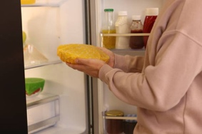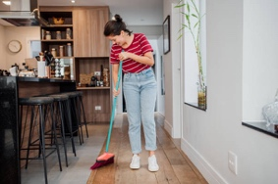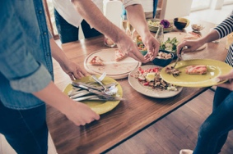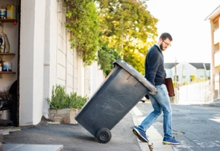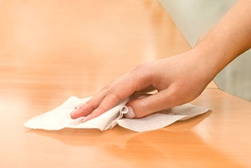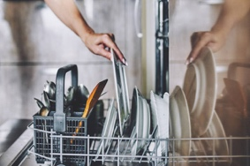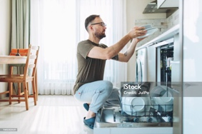­­tzz

**Simon**

**Jason**

**Greg**

**Unload Dishwasher**

**Travis**

**Jeremy**

**Rick**

**Nolan**

**Put leftovers in fridge**

**Sweep floor**

**Clear table**

**Take out trash**

**Wipe counters and table**

**Load Dishwasher**

**Kitchen**