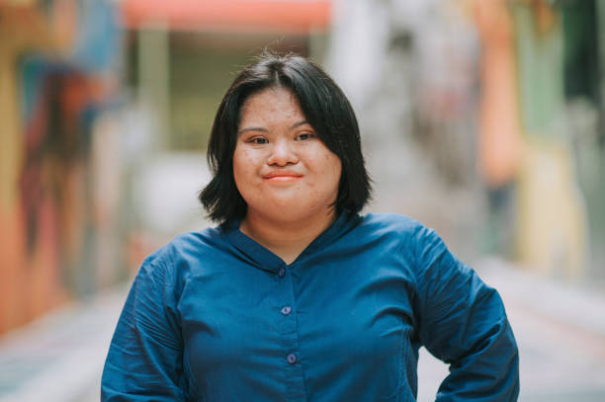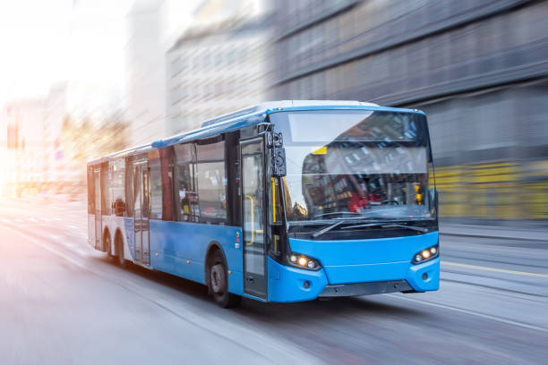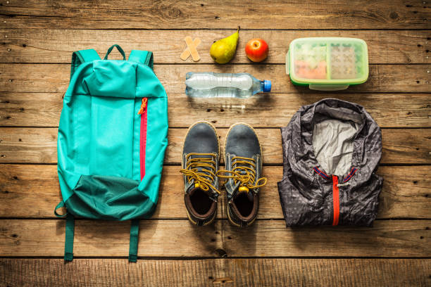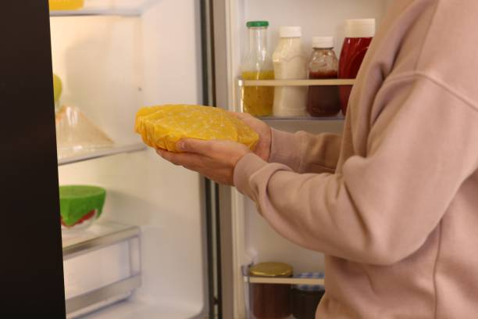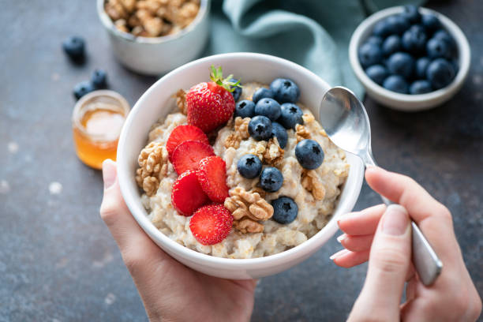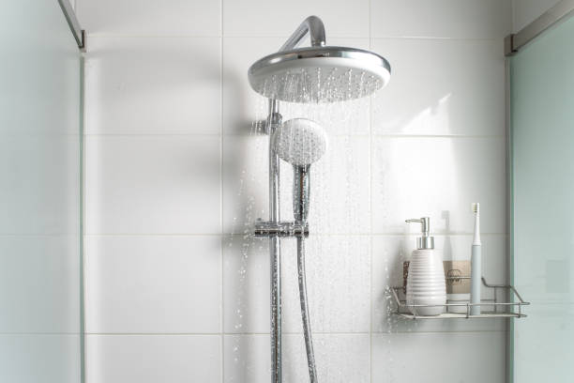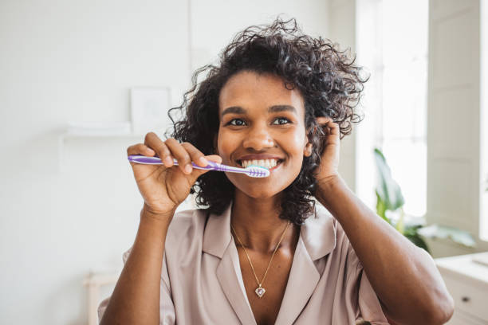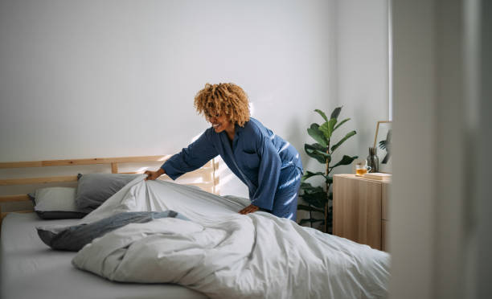­­­

[ACTIVITY]

Shower

Brush Teeth

Get Dressed

Breakfast

Put Leftovers in Fridge

Pack Backpack for the Day

Get on Bus for Progam

Make Your Bed

Wake Up!

**0:00 PM**

**9:15 AM**

**9:20 AM**

**9:25 AM**

**9:00 AM**

**8:40 AM**

**8:15 AM**

**8:20 AM**

**8:00 AM**

**7:45 AM**

**AMY’s**